SETTING UP APPLICATION ENVIRONMENT

|  |  |
| --- | --- |
| Team ID | PNT2022TMID36073 |
| Project Name | Customer Care Registry |

|  |
| --- |
| **TASK** |
| 1. Create Flask Project |
| 2. Create IBM Cloud Account |
| 3. Install IBM Cloud CLI |
| 4. Docker CLI Installation |
| 5. Create An Account in SendGrid |

1. **CREATE FLASK PROJECT**

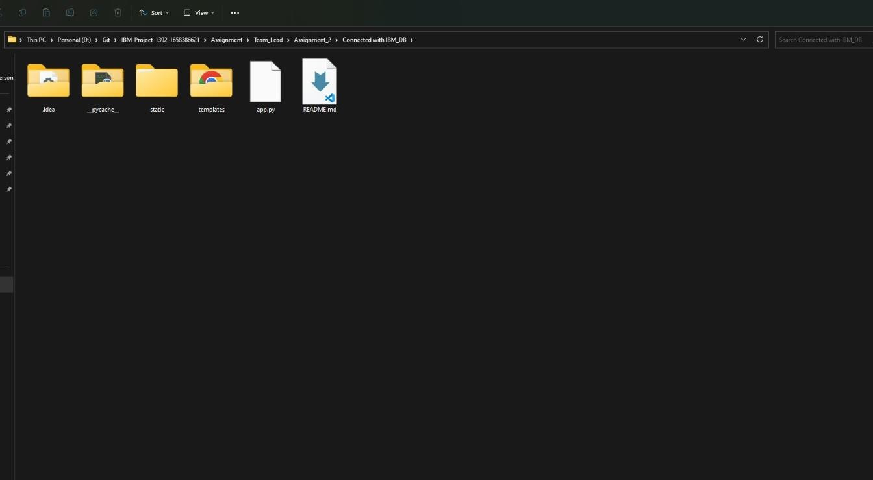

1. **CREATE IBM CLOUD ACCOUNT**

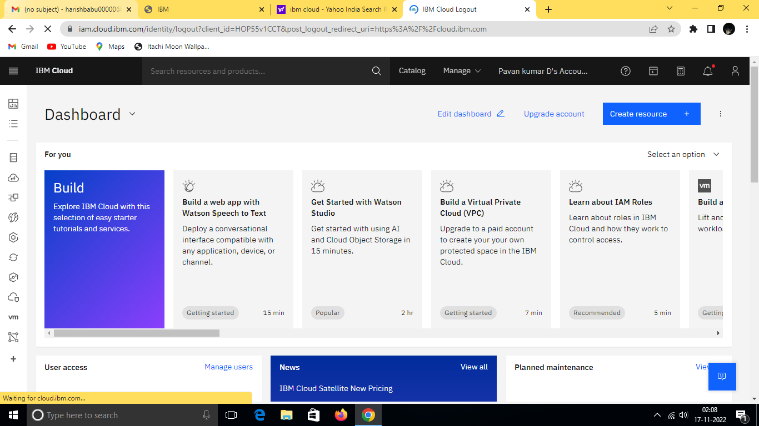

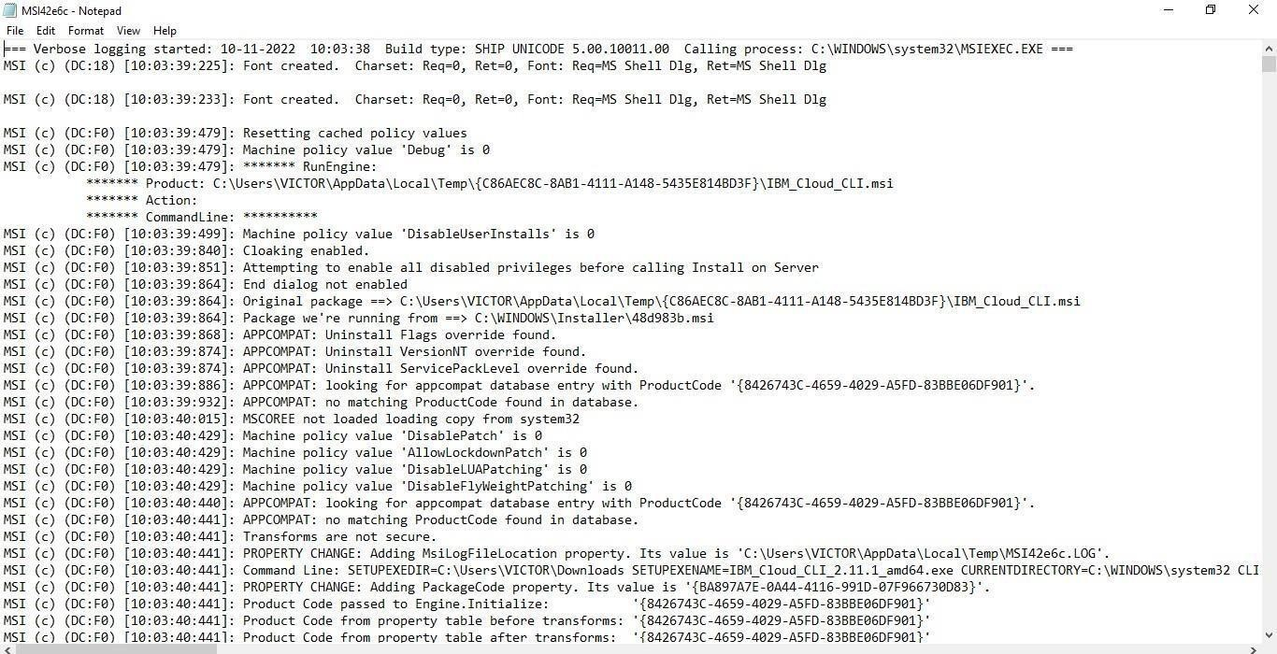

1. **INSTALL IBM CLOUD**

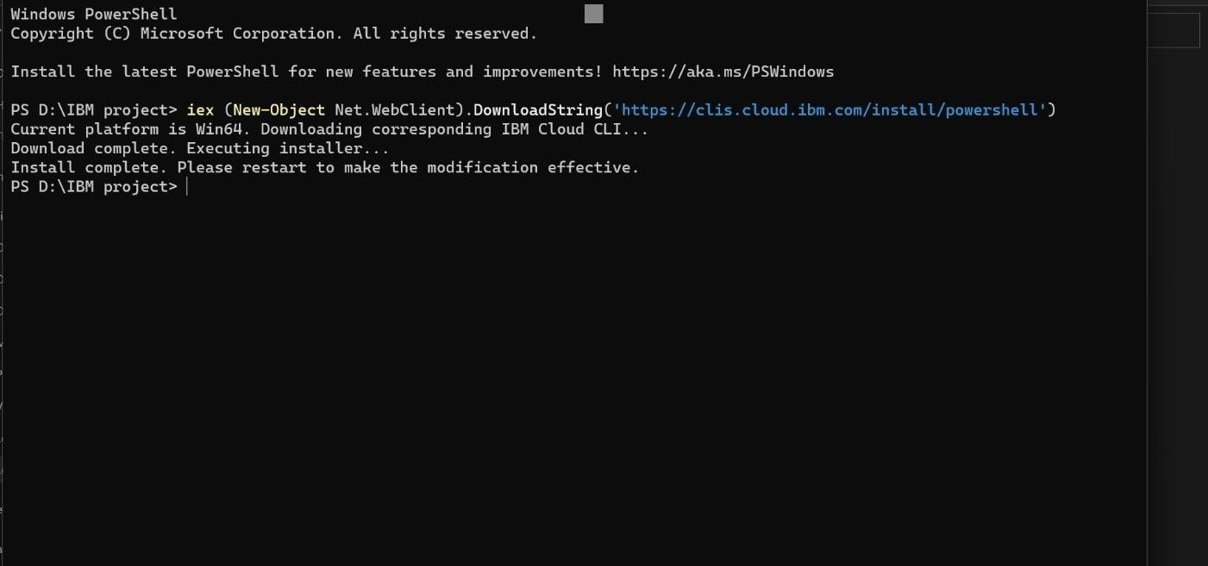

1. **DOCKER CLI INSTALLATION**

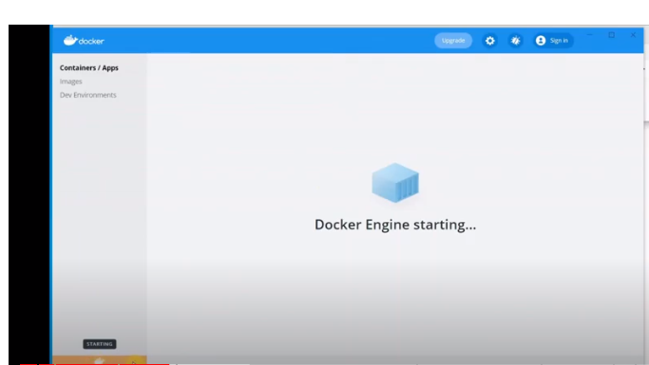

1. **CREATE AN ACCOUNT IN SENDGRID**

